IAM-Users-Assignment-–-1.
Created Users Dev1 and Dev2 and assigned to user group DevTeam
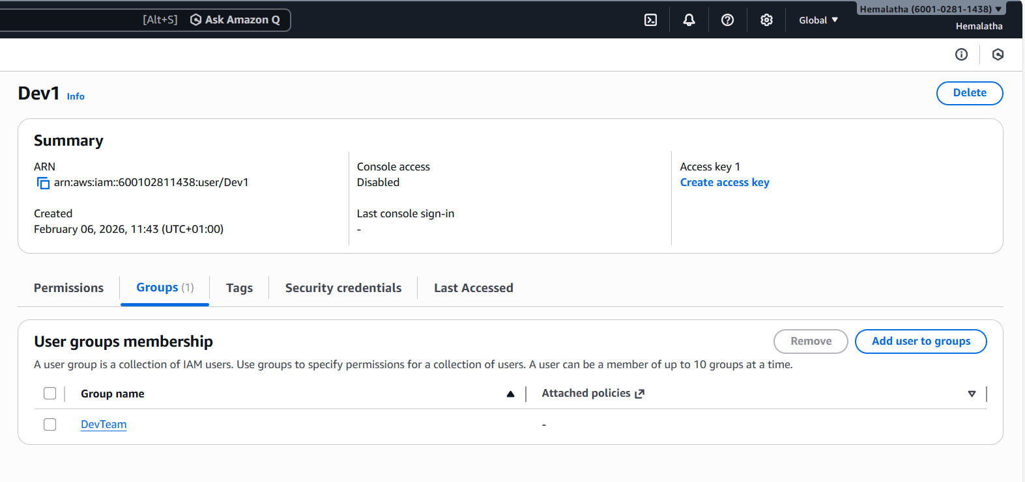
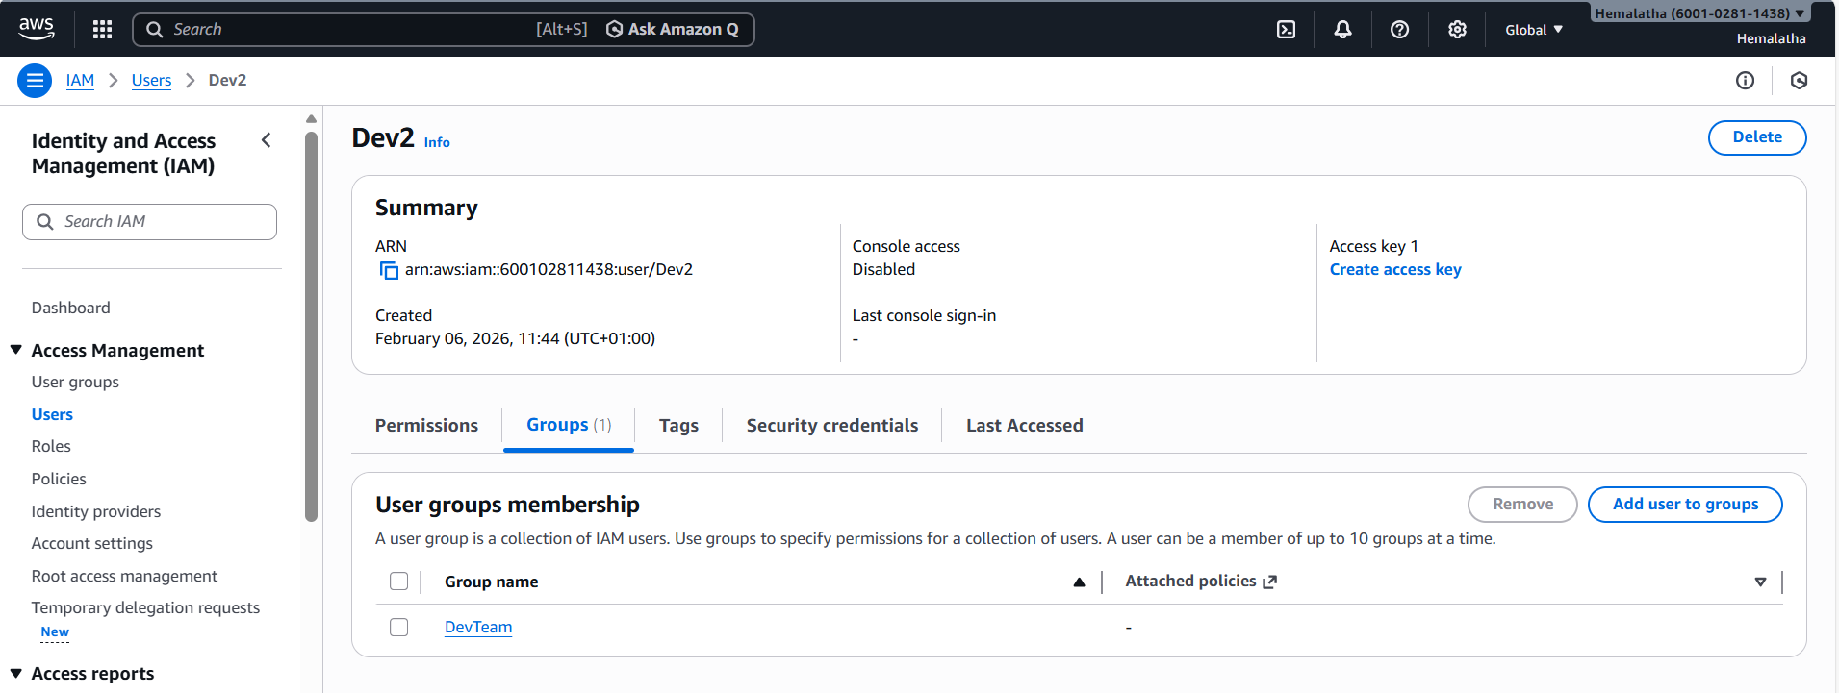

Created Users Test1 and Test2 and assigned to user group OpsTeam
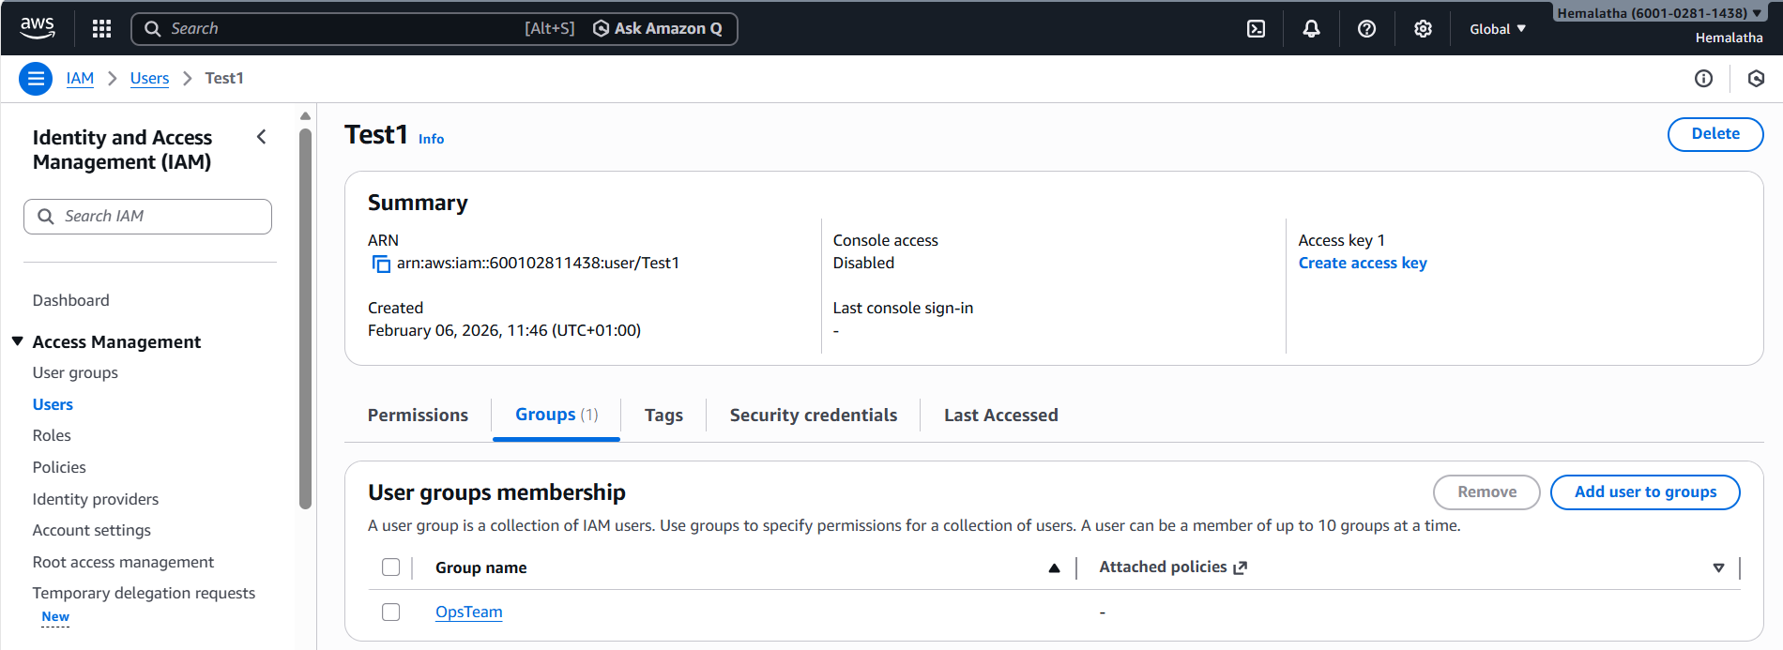
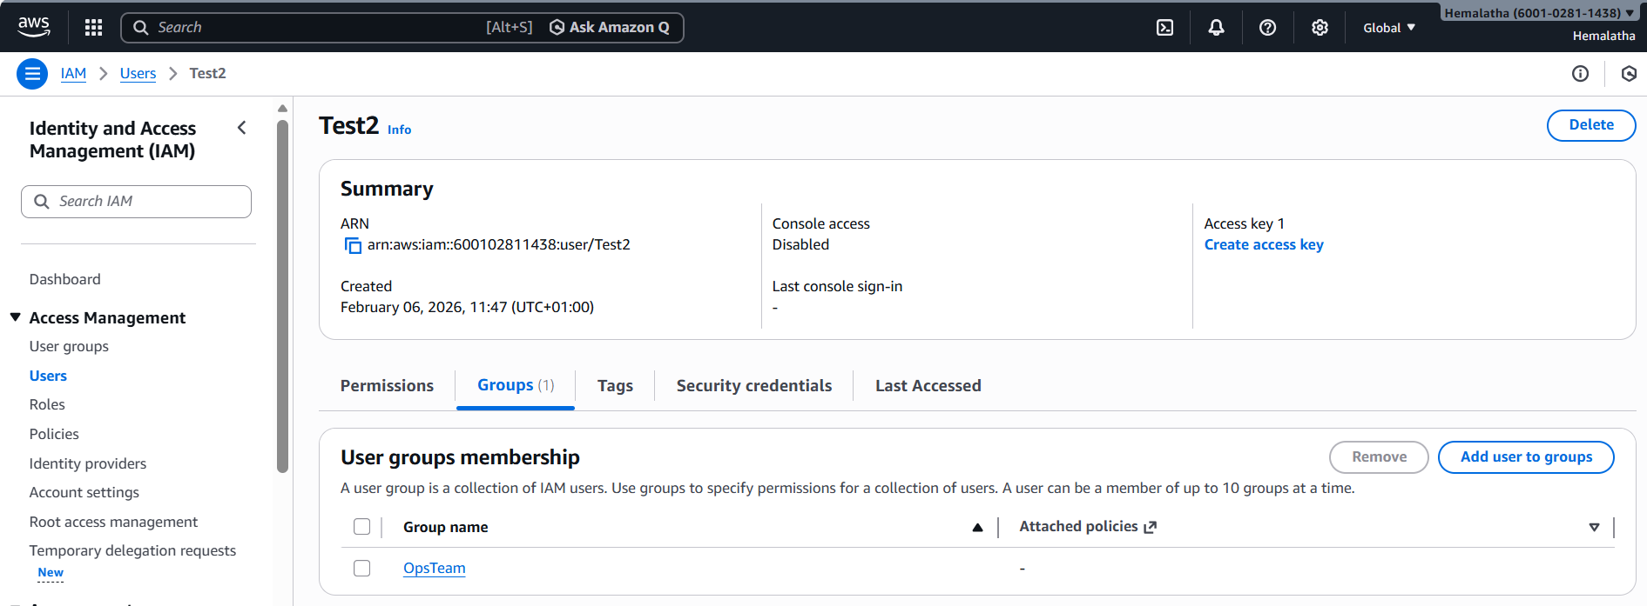

IAM-Policies-Assignment-–-2
1. Created policy number 1 “DevTeamPolicy” which lets the users to:
a. Access S3 completely
b. Only create EC2 instances
c. Full access to RDS

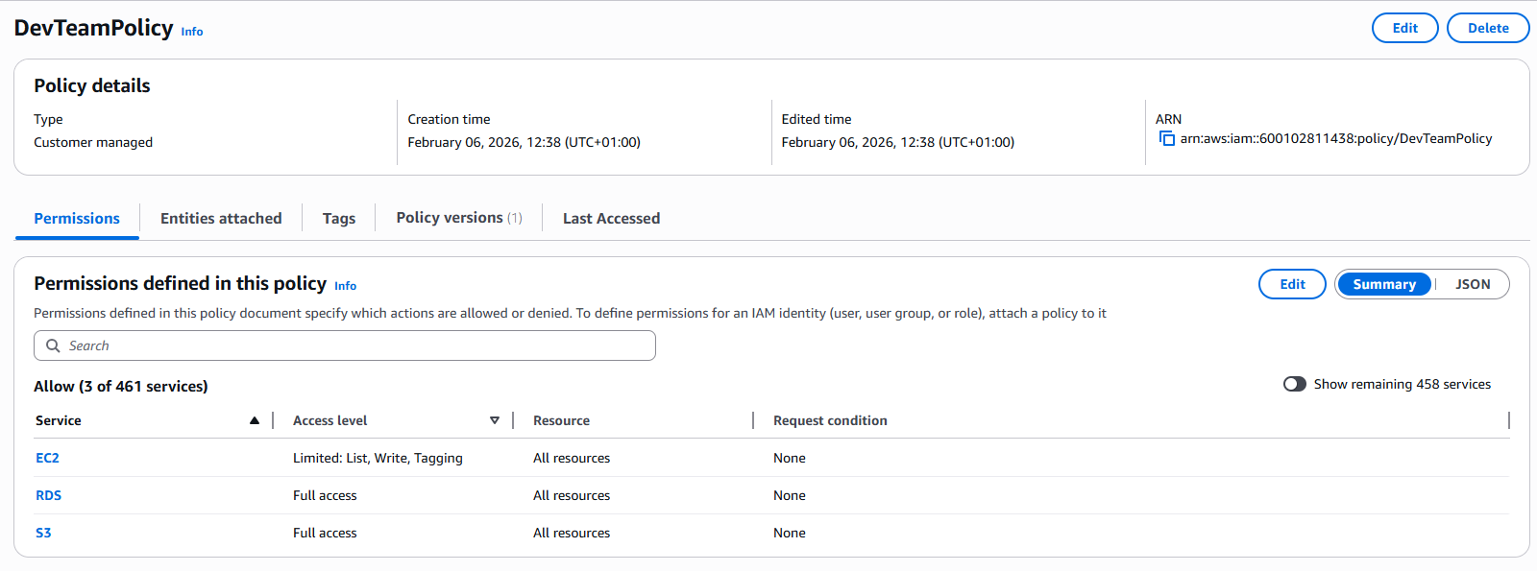

2. Creates a policy number 2 “OpsTeamPolicy” which allows the users to:
a. Access CloudWatch and billing completely
b. Can only list EC2 and S3 resources

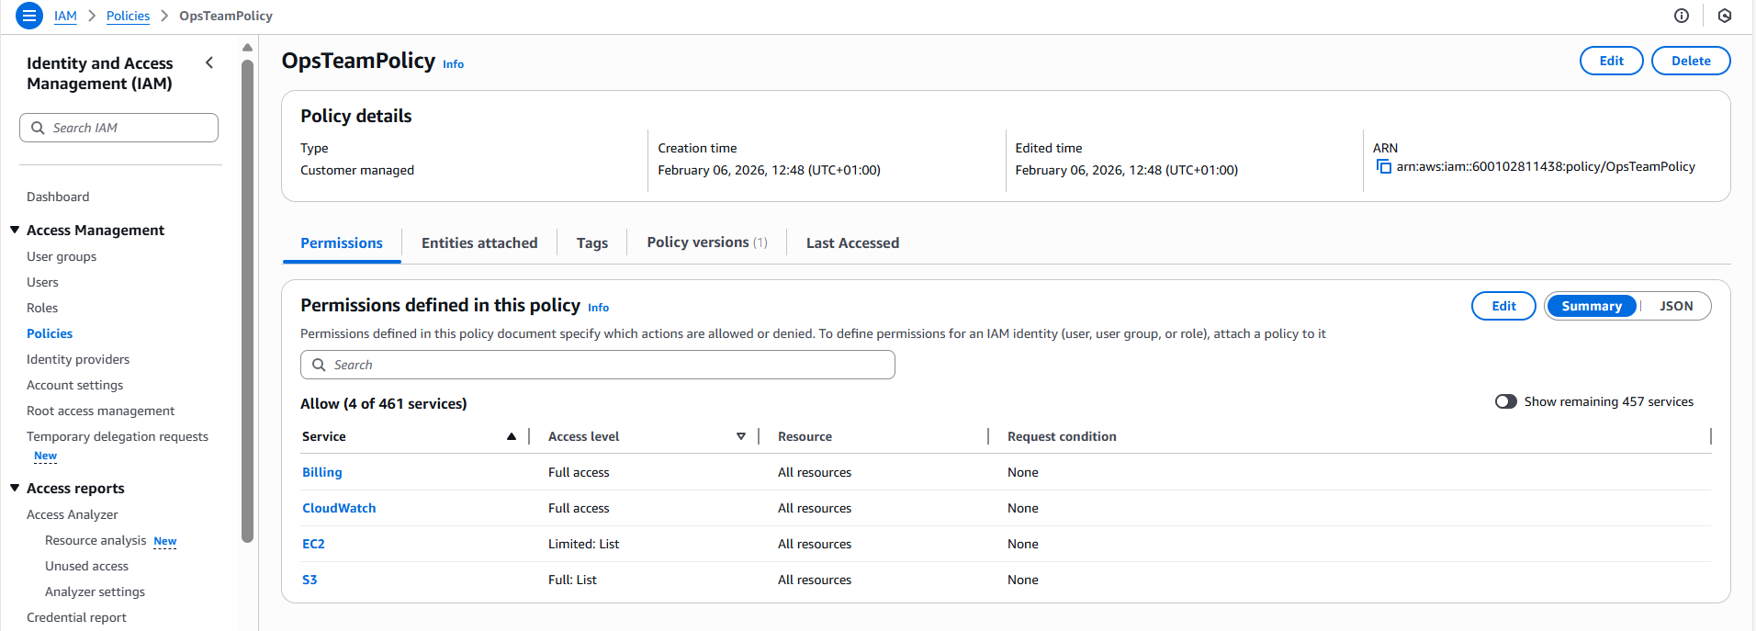

3. Attached policy number 1 “DevTeamPolicy” to user group “DevTeam” from task 1
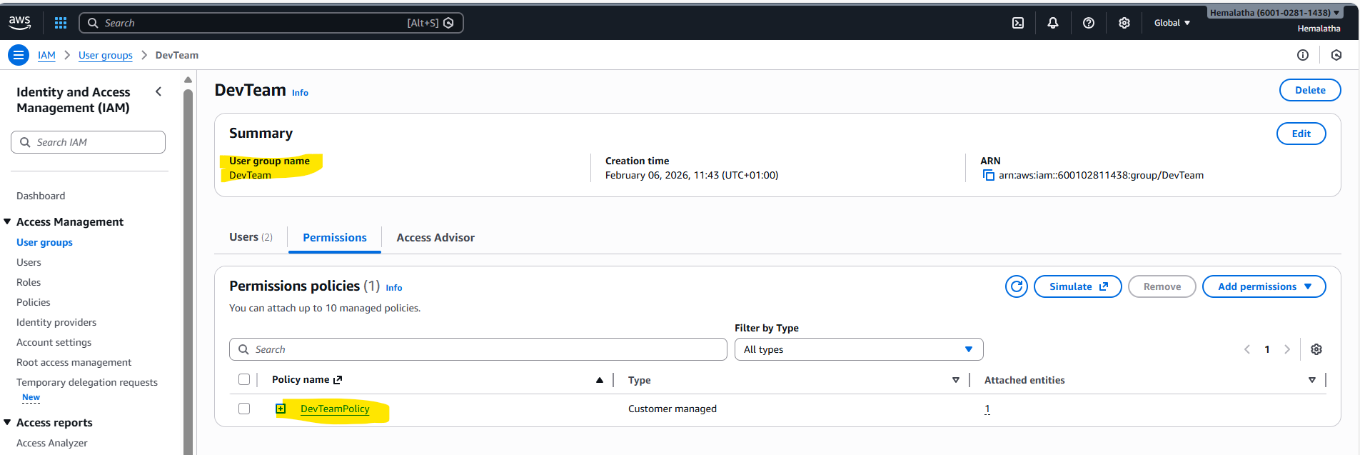

4. Attach policy number 2 “OpsTeamPolicy” to user group “OpsTeam” from task 1
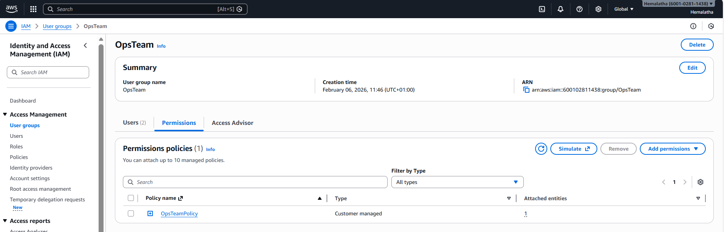

IAM-Roles-Assignment-–-3
1. Created a role “DevRole” which only lets user “Dev1” and “Dev2” from task 1 to have complete access to VPCs and DynamoDB.

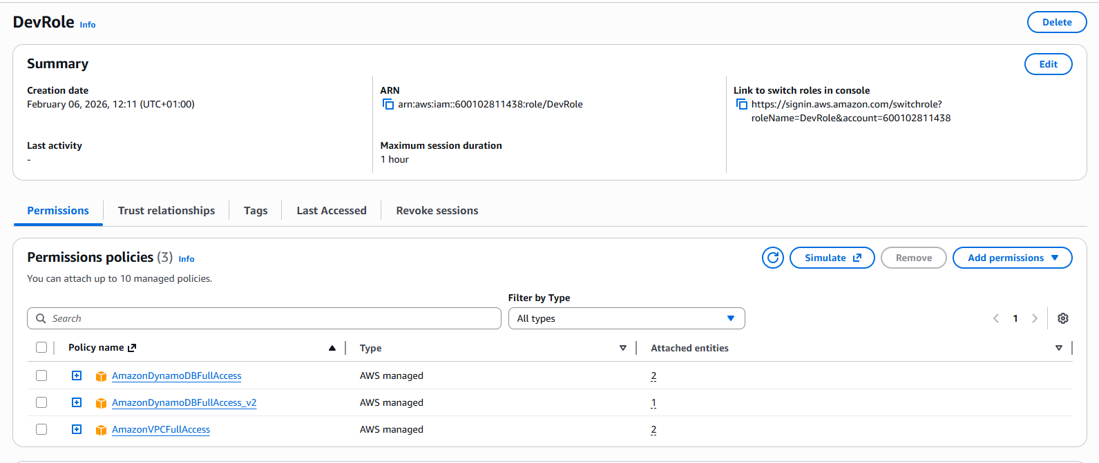
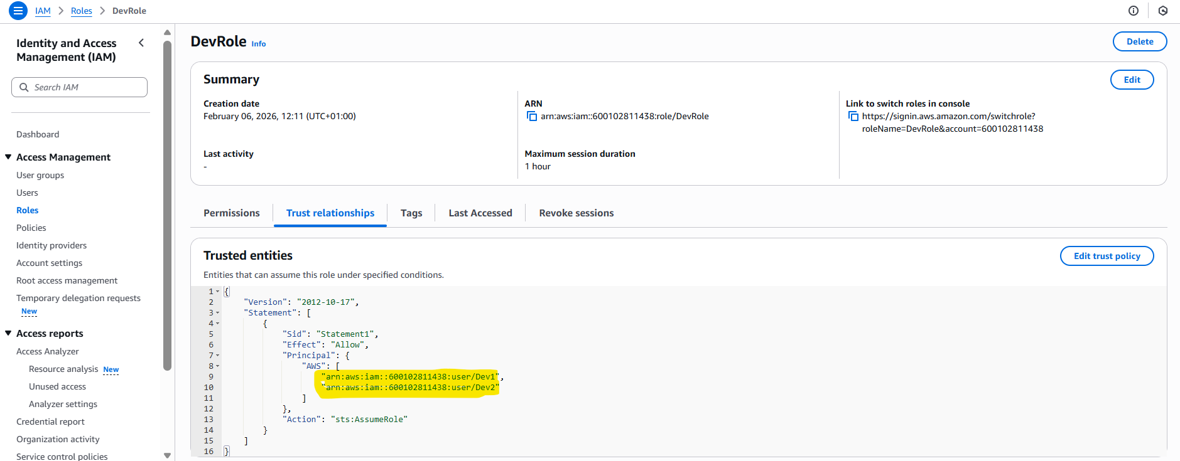

2. Logged in into user1 and shift to the role “DevRole” to test out the feature.

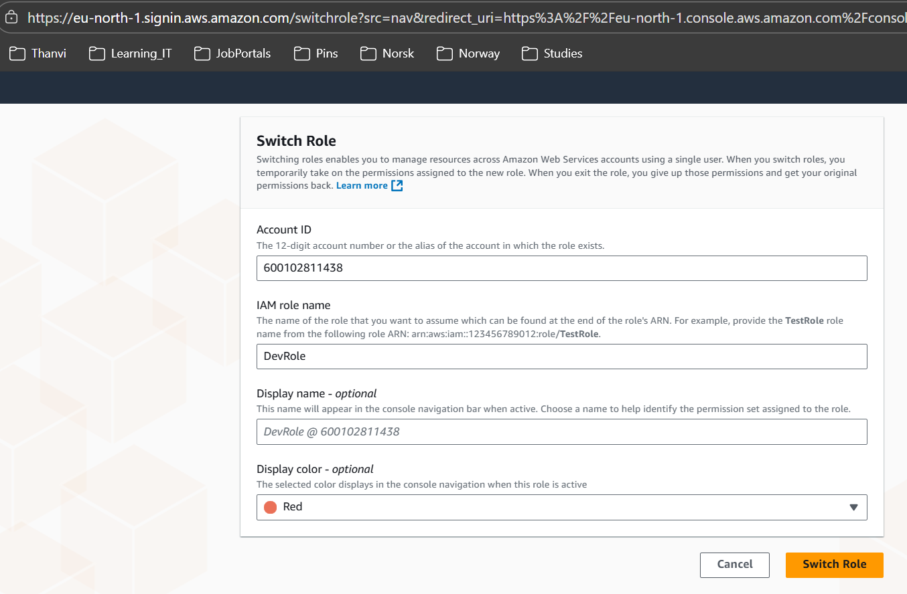

DevRole can access VPC
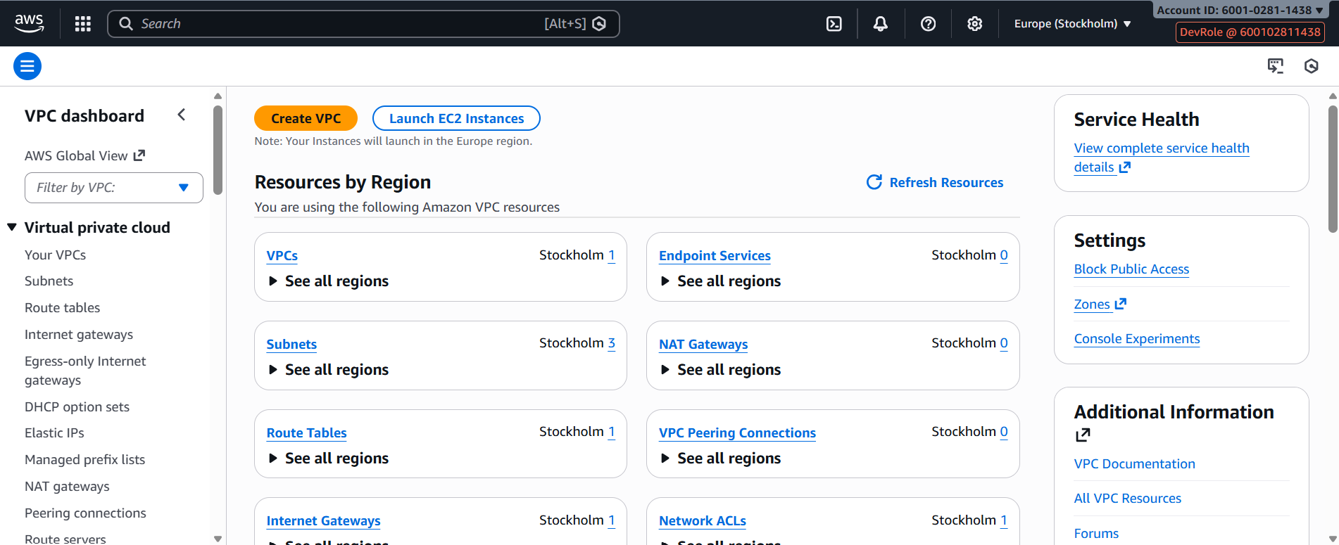

DevRole can access DynamoDB
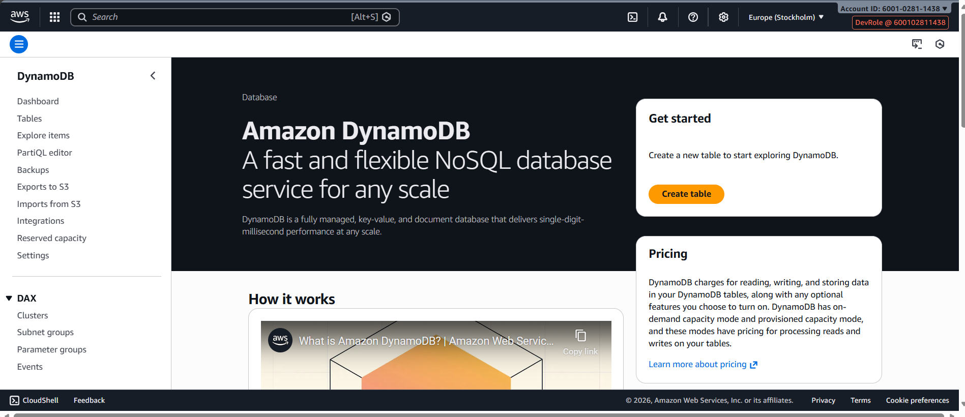

DevRole cannot access any other aws services
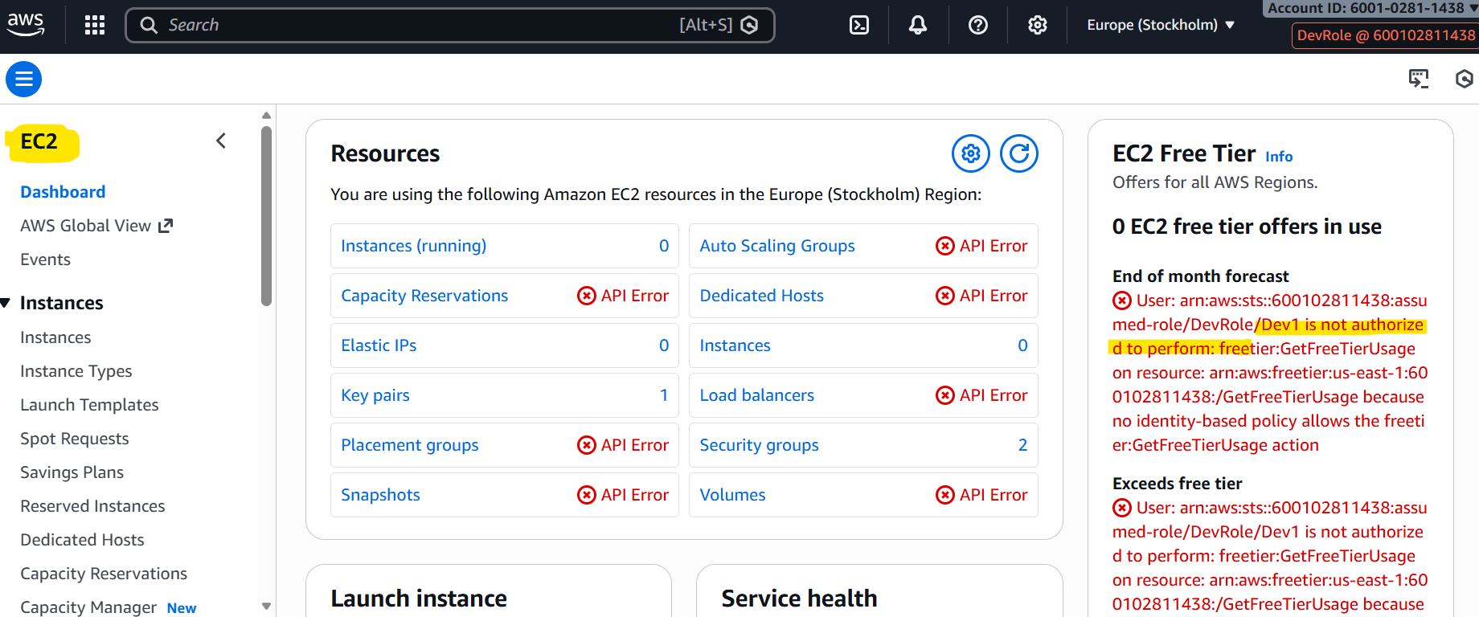

CloudWatch-Dashboard-Assignment-–-4
Created a dashboard “assignmentCloudwatch” which lets me check the CPU utilization and networking for a particular EC2 instance “assignmentCloudwatch”.

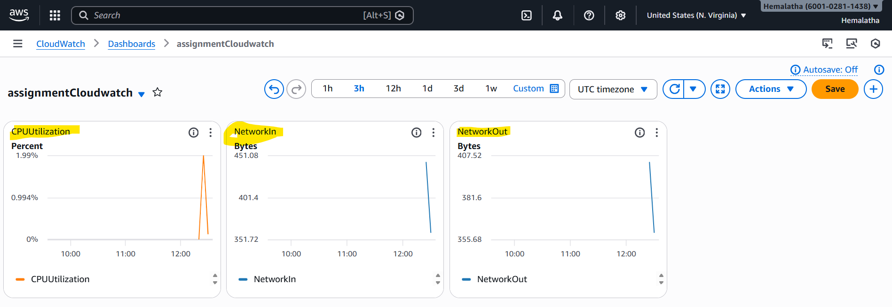

CloudWatch-Alarms-Assignment-–-5

1. Created a CloudWatch billing alarm “billingAlarm” which goes off when the estimated
charges go above $500.

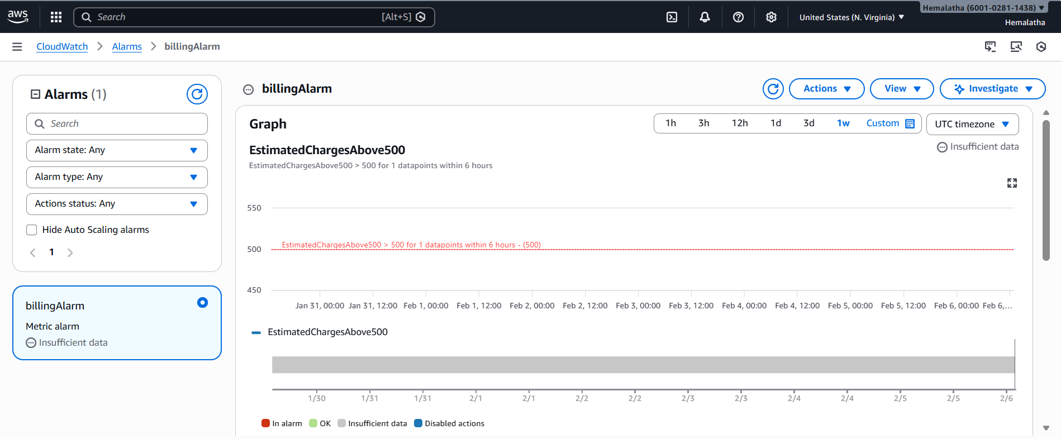

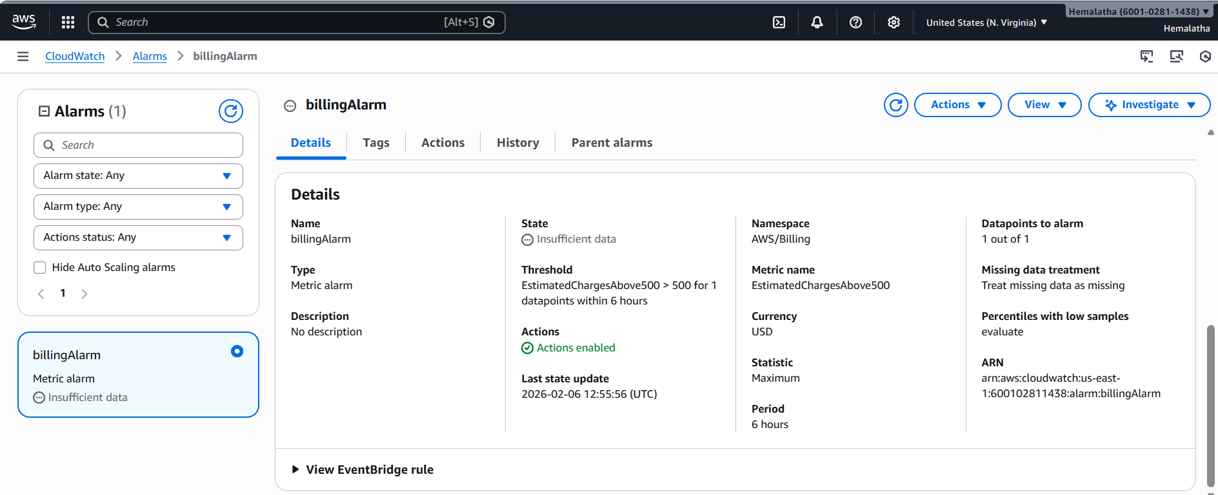

2. Created a CloudWatch alarm “HighCPUAlert” which goes off to an Alarm state when the CPU utilization of an EC2 instance goes above 65%. Also added an SNS topic “HighCPUAlert65Percent” so that it notifies the person when the threshold is crossed.

